* Open R Studio
* Along top ribbon, click on file > New Project > New Directory > R Package
* Name the package (usually all lower case if possible) and associate with a directory.
* This Creates a Folder with the Following Elements:

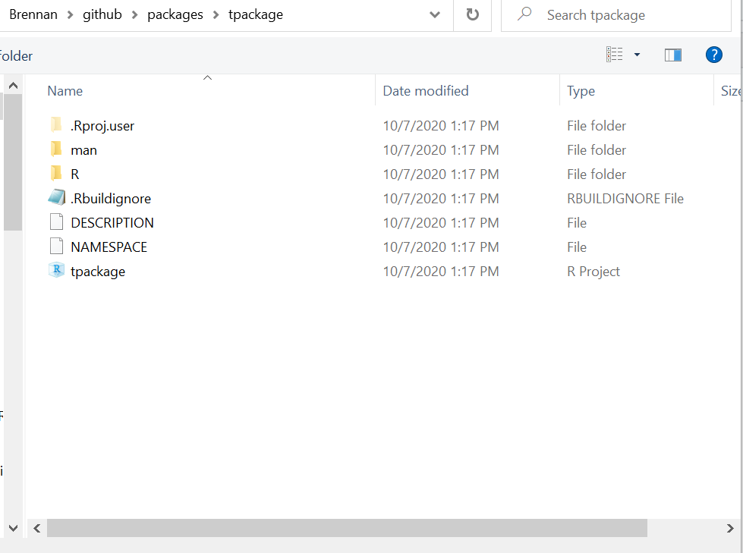

* + man: where R documentation will be stored
  + R: where you put all of your functions
  + DESCRIPTION: where you list some information about what your package does (open in notepad or another basic text editor but not Microsoft word).
* Create a new function called hello.R that does something basic.
* Use the “build” tab to install your package containing the new function.

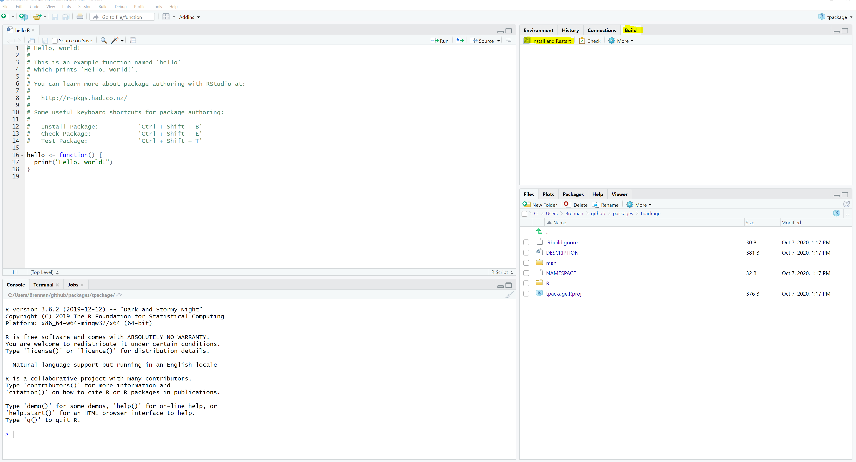

* Call your function and make sure the package works as expected.
* If you want to go farther, look at editing the description argument or using the ROxygen package to provide cleaner documentation of your functions.